

**Assignment No # 01**

**Submitted To:**

**Sir Muhammad Kamran**

**Submitted By:**

**Ayesha Altaf**

**Reg No:**

**SP20-BCS-020**

**Data:**

**2-OCT-2022**

**Question # 01:**

**A comparison of Native and Cross Platform mobile app Development?**

**Answer:**

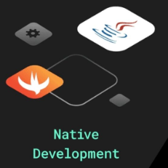 **VS**  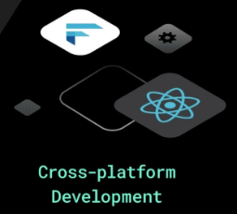

|  |  |  |
| --- | --- | --- |
| **Native** | **Cross Platform** | |
| 1. A native mobile app Development enables users to create applications for a certain operating system and programming language. | Cross-platform mobile development also allows the user to build apps that target several operating systems. | |
| 1. Native app development is the process to develop software or creating a mobile app for one native platform or device type like **(Android & IOS)** | Cross-platform apps are those that are developed to operate on multiple platforms. | |
| 1. Native Android applications using “Java” programming languages. | Cross-platform app development used for **JavaScript, C#** and Data that are common programming language. | |
| 1. A native app is easier to use and delivers better performance and high speed. | Cross-platform have lower speed and performance than its native app. | |
| 1. It contain the offline-Functionality whenever absence of internet connectivity is one of the leading benefit of native. | Cross-plat form ability to create one codebase between IOS & Android apps is one the leading benefit of cross-platform. | |
| 1. It is more interactive and very friendly. | It has complicated Development Lifecycle. | |
| 1. It enhanced the security through browsers and technologies (HTML5, JavaScript and CSS) and data protection on the user end. | | It is difficult to integrate (like code of HTML5 apps) because of call-back style programming. | |
| 1. It increase the heavy **development costs.** | | It reduced the development cost. | |
| 1. It has no code reusability, developer write unique code every time for each operating system. | | It has code reusability, developer write unique code every time for each operating system. | |
| 1. User release a mobile application on one platforms with heavy budged, time consuming, and resources. | | User release a mobile application on different platforms with limited budged, time, and resources | |
| * **Best Cross-platform Apps** * Instagram * Gmail * Evernote etc. | | * **Best Cross-platform Apps** * Insightly * Skype * Slack etc. | |

**Question # 02:**

**Different scenario where each native and cross platform mobile app development is preferred?**

**Answer:**

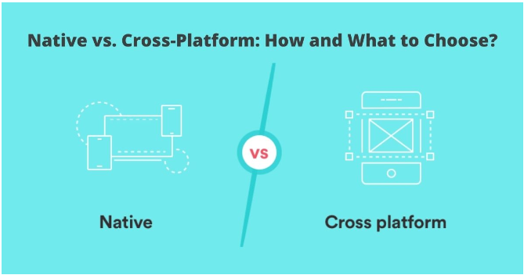

* **Native App Development**

Native app develop a single platform application. Native apps have direct access to the hardware of the single device microphone, camera.

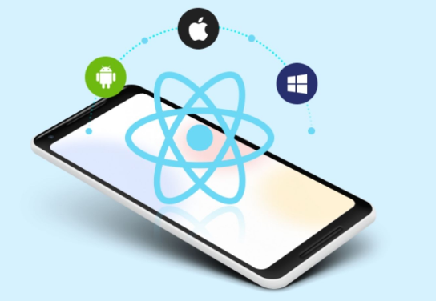 **When Should You Develop a Native App?**

* Native apps are a wonderful option if, as a business owner, you intend to create a sophisticated operation. They are ideal for creating sophisticated, high-end procedures because they can utilize all of the device's advantages.
* Native apps are a fantastic option for business owners who want to create a sophisticated operation. They are ideal for creating complex high-end procedures since they can utilize all the benefits of the gadget.
* Native app development is more expensive than cross-platform app development. Therefore, you can choose Native app development if there are no financial restrictions on your app development process.
* Native apps cost more to produce and take longer to create. Thus, stick with Native app development if you're not in a hurry to launch your app as a business owner.
* You must choose Native app development if, as a CTO, you have a team of knowledgeable Native app developers.
* There are different tools for Native app development according to the platform.
* **For Android:** Android IDE, Android Studio, IntelliJ IDEA
* **For iOS:**  Atom, X Code, App Code
* **Cross-platform app Development**

Cross-platform app development is a method for creating apps that work across several platforms. These apps are stable, easy to maintain, and iterate features.

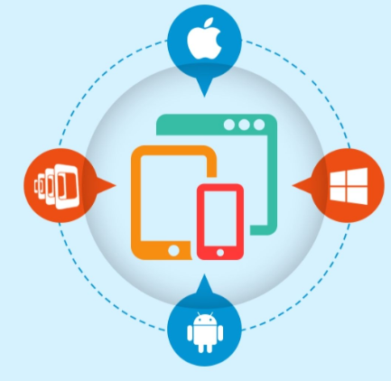 **When Should You Develop a Native App?**

* Cross-platform applications are inexpensive. Cross-platform apps are a preferable option if you are a bootstrapped firm aiming for maximum outcomes with minimal expending.
* Cross-platform apps require less upkeep. As a result, it has no adverse effects on the overall revenue of the company.
* If you are the owner of an IT company and have limited time for app promotion, cross-platform app development is a better option.
* Cross-platform apps are simpler to implement and update. Cross-platform programmers thus put you in a win-win situation as a CTO.

### *“Native Vs Cross-platform app development’ has been the* mother of all battles *in the app development realm”.*

### Conclusion:

### The functionality of an app can be developed for both native and cross-platform platforms. Before choosing an app development framework, IT business owners should be aware of what they really want. Additionally, and the decision should be based on keeping future perspectives in mind.

**Question # 03:**

**List of framework/Tech Stack for Cross plat-form mobile Application development?**

**Answer:**

React Native, Ionic Framework, Node, Xamarin, Apache Cordova, Adobe Phone Gap, and Flutter are the best mobile app development frameworks for cross-platform app development.

1. **React Native**

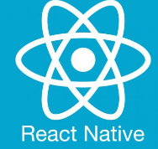

* It makes it simple to employ a single codebase across all platforms by enabling the creation of platform-specific versions of numerous functionalities.
* React Native, created and backed by Facebook, makes it easier to create mobile applications for iOS and Android Ionic Framework.

1. **Ionic**

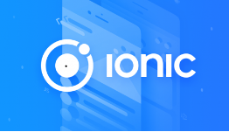

* Progressive Web Apps (PWAs), hybrid, and cross-platform mobile applications can all be created using the Ionic framework. Ionic filtration's input, views, and action sheets are its most crucial features
* App development for many platforms.
* The user interface is consistent.
* Enhanced performance.
* The flexibility of the user.

### Xamarin

### 

### A different cross-platform application development framework for creating apps for iOS and Android is called Xamarin Rapid Advancement.

### Appearance and touch of a native app.

### Compatibility with a variety of devices

### Adopt Phone Gap

### 

### This open-source mobile application development framework is frequently recognized as the best and most widely used tool for hybrid solutions.

### Sencha

### 

* Sencha is the industry leader in developing enterprise-grade apps because its comprehensive platform enables teams to concentrate on creating applications rather than frameworks.
* Cross-platform application

### Apache Cordova

### 

### It is a cross-platform application development framework that uses CSS3, HTML5, and JavaScript to create mobile apps.

### Apache Cordova, formerly known as Phone Gap, is a well-liked framework for the building of applications for developers.

### Flutter

### 

### Many well-known companies, including Google and Abbey Road Studios, have embraced Flutter.

### A quicker development.

### Cross-platform.

### Eye-catching and interesting images.

### Performance that is reasonably comparable to a native's